**MQTT Protocol**

**Introduction**

MQTT (Message Queue Telemetry Transport) is a publish /subscribe messaging protocol designed for lightweight M2M communications. It was originally developed by IBM and is now an open standard .It is an application layer protocol.

**Architecture**

MQTT has a client/server model, where every sensor is a client and connects to a server, known as a broker, over TCP.

MQTT is message oriented. Every message is a discrete chunk of data, opaque to the broker.

Every message is published to an address, known as a topic. Clients may subscribe to multiple topics. Every client subscribed to a topic receives every message published to the topic.

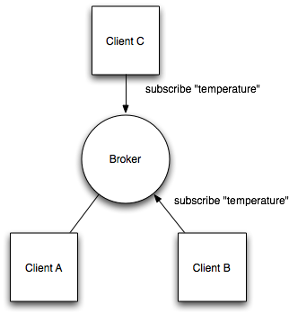

Fig No. 2